Hello world 项目总结
- 生成新的MAVEN工程。
1、执行如下命令 每次建立项目都要执行，建立maven项目，下载相关依赖。
mvn archetype:generate
-DarchetypeGroupId=org.opendaylight.controller
-DarchetypeArtifactId=opendaylight-startup-archetype -DarchetypeRepository=http://nexus.opendaylight.org/content/repositories/opendaylight.release
-DarchetypeCatalog=remote
-DarchetypeVersion=1.3.0-Carbon

2、按下回车后，一会屏幕中需要你输入一些如下信息，需要你输入的：尽量手动输入 自定义的信息（应该和后面hello项目中包名层次有关）
Define value for property 'groupId': org.opendaylight.hello 组名
Define value for property 'artifactId': hello 项目名
[INFO] Using property: version = 0.1.0-SNAPSHOT
Define value for property 'package' org.opendaylight.hello: :
Define value for property 'classPrefix' Hello: : hello 类前缀
Define value for property 'copyright': no
[INFO] Using property: copyrightYear = 2017
Confirm properties configuration:
groupId: org.opendaylight.hello
artifactId: hello
version: 0.1.0-SNAPSHOT
package: org.opendaylight.hello
classPrefix: hello
copyright: No
copyrightYear: 2017
Y: : Y

如图所示：
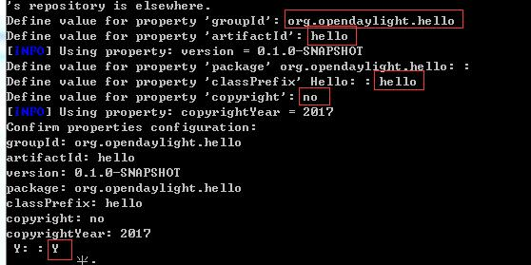

3、输入完成后，按下回车等待片刻即可出现如下页面，则完成项目框架的生成：
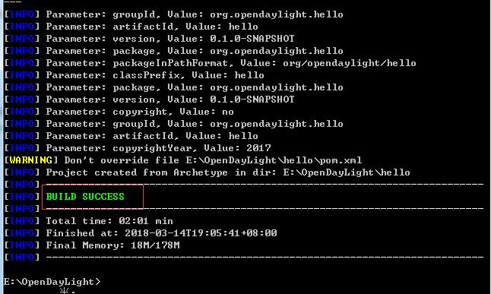
4、输入如下命令构建项目，命令第一次执行过程很长，笔者需要执行3个小时。执行成功后如图所示
mvn clean install -DskipTests //要进入hello文件夹 到现在还是maven项目
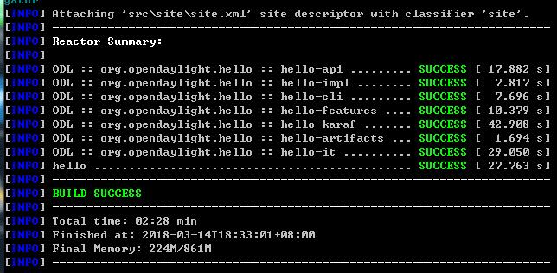
进入hello文件夹，应该有api、artifacts、cli、features、impl、it、karaf、src、target文件夹和pom.xml等文件。

二、添加HelloWorld RPC API 应该开始和ODL项目有关了
- 编辑api/src/main/yang/hello.yang文件，增加如下内容： yang是
module hello {
yang-version 1;
namespace "urn:opendaylight:params:xml:ns:yang:hello";
prefix "hello";

revision "2015-01-05" {
description "Initial revision of hello model";
}
rpc hello-world {
input {
leaf name {
type string;
}
}
output {
leaf greeting {
type string;
}
}
}
}
增加完之后执行如下指令，生成相应的接口文件：//要在hello文件夹下执行，相当于修改之后，上面的操作又执行一次
mvn clean install -DskipTests
执行成功后，如图5所示：
修改如上的yang文件后，生成如下几个类
impl/src/main/java/org/opendaylight/hello/impl/helloProvider.java
impl/src/main/resources/org/opendaylight/blueprint/impl-blueprint.xml
api/target/generated-sources/mdsal-binding/org/opendaylight/yang/gen/v1/urn/opendaylight/params/xml/ns/yang/hello/rev150105/HelloService.java

- 绑定MD-SAL
在impl/src/main/resources/org/opendaylight/blueprint/impl-blueprint.xml中添加如下代码
2  3  4  5  6  7  8  9  10  11  12  13  14  15  16  17  18  19  20  21  22  23  24  25  26  27  28 | <?xml version="1.0" encoding="UTF-8"?>  <!-- vi: set et smarttab sw=4 tabstop=4: -->  <!--  Copyright © 2017 no and others. All rights reserved.  This program and the accompanying materials are made available under the  terms of the Eclipse Public License v1.0 which accompanies this distribution,  and is available at http://www.eclipse.org/legal/epl-v10.html  -->  <blueprint xmlns="http://www.osgi.org/xmlns/blueprint/v1.0.0"  xmlns:odl="http://opendaylight.org/xmlns/blueprint/v1.0.0"  odl:use-default-for-reference-types="true">  <reference id="dataBroker"  interface="org.opendaylight.controller.md.sal.binding.api.DataBroker"  odl:type="default" />  <reference id="rpcRegistry"  interface="org.opendaylight.controller.sal.binding.api.RpcProviderRegistry"/>  <bean id="provider"  class="org.opendaylight.hello.impl.helloProvider"  init-method="init" destroy-method="close">  <argument ref="dataBroker" />  <argument ref="rpcRegistry" />  </bean>  </blueprint>

- 在impl/src/main/java/org/opendaylight/hello/impl/目录下新建HelloWorldImpl.java文件，代码如下，注释不可省略，否则编译报错：注释要一模一样
/*
* Copyright © 2017 no and others. All rights reserved.
*
* This program and the accompanying materials are made available under the
* terms of the Eclipse Public License v1.0 which accompanies this distribution,
* and is available at http://www.eclipse.org/legal/epl-v10.html
*/

package org.opendaylight.hello.impl;
import java.util.concurrent.Future;
import org.opendaylight.yang.gen.v1.urn.opendaylight.params.xml.ns.yang.hello.rev150105.HelloService;
import org.opendaylight.yang.gen.v1.urn.opendaylight.params.xml.ns.yang.hello.rev150105.HelloWorldInput;
import org.opendaylight.yang.gen.v1.urn.opendaylight.params.xml.ns.yang.hello.rev150105.HelloWorldOutput;
import org.opendaylight.yang.gen.v1.urn.opendaylight.params.xml.ns.yang.hello.rev150105.HelloWorldOutputBuilder;
import org.opendaylight.yangtools.yang.common.RpcResult;
import org.opendaylight.yangtools.yang.common.RpcResultBuilder;
public class HelloWorldImpl implements HelloService{
@Override
public Future<RpcResult<HelloWorldOutput>> helloWorld(HelloWorldInput input) {
HelloWorldOutputBuilder helloBuilder = new HelloWorldOutputBuilder();
helloBuilder.setGreeting("Hello " + input.getName());
return RpcResultBuilder.success(helloBuilder.build()).buildFuture();
}
}

- 在impl/src/main/java/org/opendaylight/hello/impl/目录下修改helloProvider文件，增加如下代码 尽量
/*
* Copyright © 2017 no and others. All rights reserved.
*
* This program and the accompanying materials are made available under the
* terms of the Eclipse Public License v1.0 which accompanies this distribution,
* and is available at http://www.eclipse.org/legal/epl-v10.html
*/
package org.opendaylight.hello.impl;

import org.opendaylight.controller.md.sal.binding.api.DataBroker;
import org.opendaylight.controller.sal.binding.api.BindingAwareBroker.RpcRegistration;
import org.opendaylight.controller.sal.binding.api.RpcProviderRegistry;
import org.opendaylight.yang.gen.v1.urn.opendaylight.params.xml.ns.yang.hello.rev150105.HelloService;
import org.slf4j.Logger;
import org.slf4j.LoggerFactory;

public class helloProvider {

private static final Logger LOG = LoggerFactory.getLogger(helloProvider.class);
private final DataBroker dataBroker;
private final RpcProviderRegistry rpcProviderRegistry;
private RpcRegistration<HelloService> serviceRegistration;

public helloProvider(final DataBroker dataBroker, RpcProviderRegistry rpcProviderRegistry) {
this.dataBroker = dataBroker;
this.rpcProviderRegistry = rpcProviderRegistry;
}

/**
* Method called when the blueprint container is created.
*/
public void init() {
serviceRegistration = rpcProviderRegistry.addRpcImplementation(HelloService.class, new HelloWorldImpl());
LOG.info("helloProvider Session Initiated");
}

/**
* Method called when the blueprint container is destroyed.
*/
public void close() {
serviceRegistration.close();
LOG.info("helloProvider Closed");
}
}
- 编译及验证
- 执行如下指令，对刚才所修改的代码进行编译
mvn clean install -DskipTests
- 编译完成后，启动OpenDayLight，如图所示：启动hello文件夹中的..\hello\karaf\target\assemble#.\bin\karaf
F:\OpenDayLight\hello\karaf\target\assembly\bin>karaf
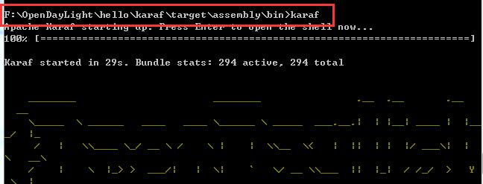
- 在浏览器中输入如下地址（账号密码：admin\admin）
http://localhost:8181/apidoc/explorer/index.html
显示如图7所示，找到新增的hello
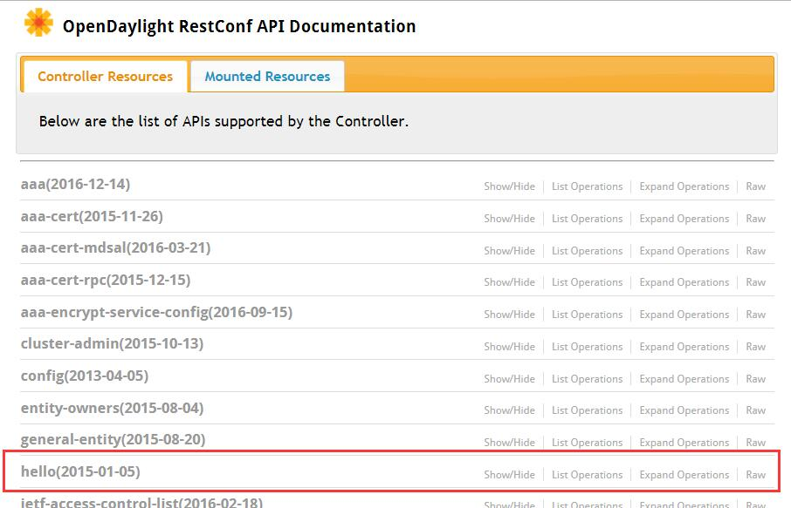
- 双击hello栏，如图显示
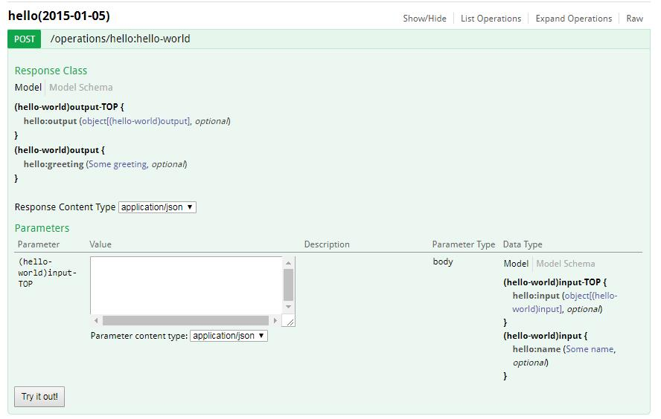
- 在Value中输入如下的值后，点击Try it out，返回如图9结果，即验证HelloWorld成功。
{"hello:input": { "name":"hello"}}
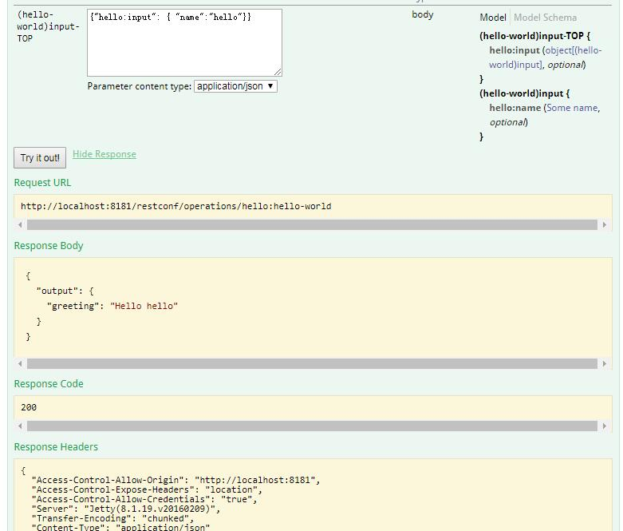

四、集成到发行版中

1. 将hello工程复制到ODL发行版中
cd /opt/Carbon/distribution-karaf-0.6.0-Carbon/system/org/opendaylight
sudo mkdir hello
sduo cp -r /opt/maven/repository/org/opendaylight/hello*
/opt/Carbon/distribution-karaf-0.6.0-Carbon/system/org/opendaylight/hello
- 启动ODL
cd /opt/Carbon/distribution-karaf-0.6.0-Carbon
./bin/karaf
- 将Hello 仓库添加到featue list中
opendaylight-user@root>feature:repo-add mvn:org.opendaylight.hello/hello-features/0.1.0-SNAPSHOT/xml/features
其中mvn:org.opendaylight.hello/hello-features/0.1.0-SNAPSHOT/xml/features的具体值在\hello\karaf\target\assembly\etc\org.apache.karaf.features.cfg 文件的最后部分：
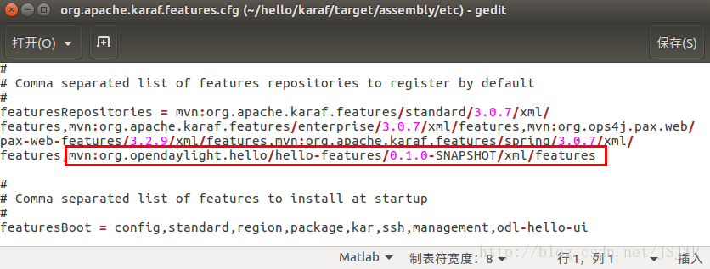
- 查看hello是否安装并安装
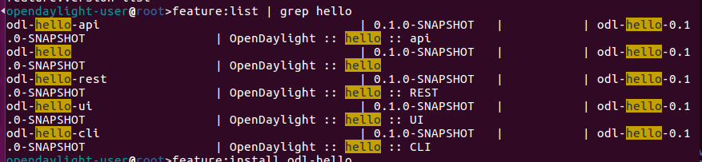
如果要将hello移除feature list，可以使用
feature:repo-remove mvn:org.opendaylight.hello/hello-features/0.1.0-SNAPSHOT/xml/features
- 在webUI上查看是否成功将hello集成到ODL中
登录页面http://127.0.0.1:8181/index.html，可在YANG UI/API中找到相应的功能，进行测试

错误：
关于解决构建maven项目中报错：Failed to execute goal org.apache.maven.plugins:maven-archetype-plugin:3.0.1...:的方法：
1.首先进入仓库下面repository\org\apache\maven\plugins这个目录
2.删除目录下的maven-archetype-plugin文件夹
3.重新加载

